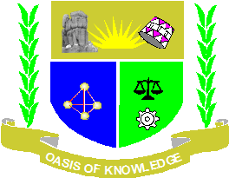
JARAMOGI OGINGA ODINGA UNIVERSITY OF SCIENCE AND TECHNOLOGY
SCHOOL OF EDUCATION, HUMANITIES AND SOCIAL SCIENCES
DEPARTMENT OF SOCIAL STUDIES
UNIVERSITY EXAMINATION FOR THE DEGREE OF BACHELOR OF ARTS IN INTERNATIONAL RELATIONS AND DEPLOMACY WITH IT
4TH YEAR 2ND SEMESTER 20212022 ACADEMIC YEAR
NAIROBI CAMPUS
COURSE CODE: ZHB 3406
COURSE TITLE: RACE AND THE AFRICA DIASPORA IN IR
EXAM VENUE:
DATE: 12/07/2022 STREAM: (IR)
TIME: 2.00 HOURS EXAM SESSION: 3.00 – 5.00PM
INSTRUCTION
- Answer question ONE (compulsory) and ANY other TWO question
- Candidates are advised not write on the question paper.
- Candidates must hand in their answer booklets to the invigilator while in the examination room.

1(a). Explain the concept of the term “Race” (5 marks)
1(b). Discuss the origin of the diaspora giving examples of the reason receiving or hosting countries (10 marks)
1(c). Discrimination, unequal job opportunities are the critical issues affecting Race relations in developed western world. What is the position of United Nation on human right advocacy? (15 marks)
- How does Race and Ethnicity undermine social, political and economic development in the developing Nation especially Africa? (20 marks)

- With specific examples describe the role of Africans in Diaspora who championed for independent Africa after Second World War (20 marks)

- Outline the positive and negative social, economic and political impact of African diaspora in independent Africa. (20 marks)

- Migration in search for better life and employment opportunities in Western World is the current problem challenging African states. What advices would you give to control the situation? (20 marks)

