JARAMOGI OGINGA ODINGA UNIVERSITY OF SCIENCE AND TECHNOLOGY
SCHOOL OF BIOLOGICAL AND PHYSICAL SCIENCES
UNIVERSITY EXAMINATION FOR THE DEGREE OF BACHELOR OF EDUCATION (SCIENCES)
4RD YEAR SECOND SEMESTER 2019/2020 ACADEMIC YEAR
MAIN REGULAR
COURSE CODE: SCH 408
COURSE TITLE: STATISTICAL THERMODYNAMICS
EXAM VENUE: DATE:
TIME: EXAM SESSION:
STREAM:
INSTRUCTIONS:
- Answer question 1 (Compulsory) in section A and ANY other 2 questions in Section B.
- Candidates are advised not to write on the question paper.
- Candidates must hand in their answer booklets to the invigilator while in the examination room.

SECTION A (30 MARKS)
Question 1.
- Explain the difference between classical and statistical thermodynamics (4 marks)
- Explain what is meant by;
- Population of a state (2 marks)
- Thermodynamic system (2 marks)
- Property of a system (2 marks)
- Weight of a configuration (2 marks)
- i) Write an expression for the weight of a configuration (2 marks)
- Calculate the number of ways of distributing 20 identical objects with the arrangement 1, 0, 3, 5, 10, 1. (2 marks)
- The Boltzmann distribution is given by the equation;
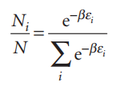
Where
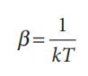
- Explain the significance of T. (3 marks)
- State the importance of the Boltzmann distribution (2 marks).
- Define the term Internal Energy (2 marks)
- How is the internal energy related to the derivative of the partition function (3 marks)
- What is the significance of the molecular partition function (4 marks)

SECTION B
Question 2 (20 marks)
- What is meant by, ‘a canonical ensemble’ (2 marks)
- State the first and second laws of thermodynamics (2 marks)
- Describe the usefulness of statistical thermodynamics (4 Marks)
- The molecular partition function is given by;
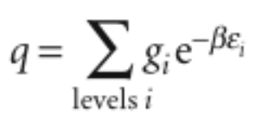
Explain what happens to q at low and high temperatures (5 marks).
- Evaluate the partition function for a molecule with an infinite number of equally
spaced non-degenerate energy levels (figure below). These levels can be thought of as
the vibrational energy levels of a diatomic molecule in the harmonic approximation (7 marks)
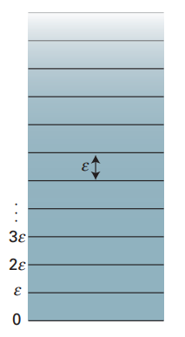
Question 3 (20 marks)
- Write an expression for the partition function of a linear molecule (such as HCl)
treated as a rigid rotor. (10 marks)
- Derive an expression for the relation between internal energy (U) and the partition function (q). (10 marks)
Question 4 (20 marks).
- Write the partition function for a particle in a one-dimensional box (10 marks)
- Derive an expression for the pressure of a gas of independent particles (10 marks)
Question 5 (20 marks).

- The Boltzmann formula for the entropy is given by the equation;
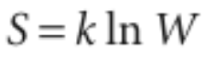
Explain what happens to W and hence S as the temperature is lowered. (5 marks)
- The Sackur–Tetrode equation for the entropy of a monatomic gas is given by;
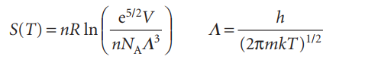
- What does it imply ( 5 marks)
- Because the gas is perfect, use the relation V = nRT/p to express the entropy in terms of the pressure (5 marks)
- The energy of a molecule is the sum of contributions from its different modes of
motion. Explain (5 marks)

