
JARAMOGI OGINGA ODINGA UNIVERSITY OF SCIENCE AND TECHNOLOGY
SCHOOL OF EDUCATION, HUMANITIES AND SOCIAL SCIENCES
UNIVERSITY EXAMINATION FOR THE DEGREE OF MASTER OF EDUCATION (EDUCATIONAL ADMINISTRATION/CURRICULUM STUDIES/PEDAGOGY)
1ST YEAR 1ST SEMESTER 2022/2023 ACADEMIC YEAR
REGULAR PROGRAMME
MAIN CAMPUS
COURSE CODE: ECT 804/EMA 858
COURSE TITLE: COMPUTER APPLICATION IN RESEARCH
DATE: 28/07/2022 EXAMS SESSION: 9.00 - 12.00NOON
TIME: 3 HOURS
_____________________________________________________________________________
INSTRUCTIONS
- Answer any THREE questions.
- Candidates are advised not to write on the question paper.
- Candidates must hand in their answer booklets to the invigilator while in the examination
room
QUESTION ONE
a. Explain the meaning of data coding and indicate why it is necessary in research.
(4 marks)
b. Justify why descriptive statistics would be useful to a researcher? (3 marks)

c. A researcher collected data from four schools in two counties concerning the perception of the students about some aspects of their school. The schools were St. Anne, St. Cecilia, St. Ignatius and St. Paul and the counties were Nairobi and Nakuru. The questionnaire for data collection is shown below:-

Students’ questionnaire

- County …………
- School …………
- Gender …………
- Age …………
- Indicate your level of agreement with the statements after the key below

KEY
1 = Strongly disagree
2 = Disagree
3 = Undecided
4 = Agree
5 = Strongly Agree

- My school is the best 1 2 3 4 5
- Our head teacher is hard working 1 2 3 4 5
- Our deputy is hard working 1 2 3 4 5
- We have the best diet 1 2 3 4 5
- We are a disciplined school 1 2 3 4 5
- Our school meets all Covid-19 protocols 1 2 3 4 5
- We understand everything when taught 1 2 3 4 5
- Our school is well equipped 1 2 3 4 5
- Our school is adequately staffed 1 2 3 4 5
- We have a good relationship with community 1 2 3 4 5
- We perform better than other schools 1 2 3 4 5
- Primary school pupils prefer our school 1 2 3 4 5

Use the above questionnaire to answer the questions that follow:-
- Prepare a code book for the data that would be collected. (9 mks)
- From the questionnaire which data items would you consider to be:
  - Continuous variables. (2 mks)
  - Categorical variables (2 mks)

QUESTION TWO
- Describe the characteristics of data that would warrant application of parametric tests
(4 mks)
(b) A researcher wanted to find out whether there was a significant difference between the total optimism score on the optimism scale across three age groups. While analyzing the data by conducting an ANOVA test using SPSS, the researcher obtained the output shown in tables below. Use the output tables to answer the questions that follow.

Output from a one-way between groups ANOVA

One way
Descriptive
Total Optimism
 | N | Mean | Std.  Deviation | Std.  Error | 95% Confidence  Interval for Mean |  | Minimum | Maximum
 |  |  |  |  | Lower  Bound | Upper  Bound | Minimum | Maximum
1 18-29  2 30-44  3 45+  Total | 147  153  135  435 | 21.36  22.10  22.96  22.12 | 4.551  4.147  4.485  4.429 | 375  335  386  212 | 20.62  21.44  22.19  21.70 | 22.10  22.77  23.72  22.53 | 7  10  8  7 | 30  30  30  30

Test of Homogeneity of variance
Total Optimism
Levene  Statistic | df1 | df2 | Sig.
746 | 2 | 432 | .024

ANOVA
Total Optimism
 | Sum of  Squares | Df | Mean Square | F | Sig.
Between Groups  Within Groups  Total | 179.089  833.951  8513.021 | 2  432  434 | 89.535  19.292 | 4.641 | .010

Robust Tests Of Equality Of Means
Total Optimism
 | Statistic | df1 | df2 | Sig.
Welch  Brown-Forsythe | 4.380  4.623 | 2  2 | 284.508  423.601 | .013  .010

Multiple Comparisons
Dependent Variable: Total Optimism
Tukey HSD
(I)Age.3 groups (J)age 3 groups | Mean  Difference  (I-J) | Std. Error | Sig | 95% Confidence Interval
 |  |  |  | Lower Bound | Upper Bound
1 18-29 2 30-44  3 45+ | -.744  -1.595* | .507  .524 | .308  .007 | -1.94  -2.83 | .45  -.36
2 30-44 1 18-29  3 45+ | -.744  -.851 | .507  .519 | .308  .230 | -.45  -2.07 | 1.94  .37
3 45+ 1 18-29  2 30-44 | 1.595*  .851 | .524  .519 | .007  .230 | .36  -.37 | 2.83  2.07
* The mean difference is significant at the 0.05 level

- What is the importance of the multiple comparisons table in the output? (4 mks)
(ii) By giving reasons, explain whether or not the assumption of homogeneity of variances was violated. (2 mks)
(iii) By giving reasons, explain whether or not there was a significant difference between
the groups. (4 mks)
- Describe the procedure for conducting a one-way between groups ANOVA with post-hoc tests. (6 mks)

QUESTION THREE
A researcher conducted a research to explore sex differences in self-esteem scores and obtained the output as shown in the tables below. Use the output tables to answer the questions that follow:-

The output generated from this procedure is shown below
Group Statistics
SEX | N | Mean | Std. Deviation | Std. Error Mean
Total self MALES  esteem FEMALES | 484  352 | 34.02  33.17 | 4.91  5.71 | 36  36

Independent samples t-test
 | Levene's Test for Equality of Variances |  | t-test for Equality of Means
 | F | Sig. | T | Df | Sig.  (2-tailed) | Mean  Difference | Std. Error  Difference | 95% Confidence  Interval of the  Difference
 |  |  |  |  |  |  |  | Lower | Upper
Total Equal variances  self assumed  esteem Equal variances  not assumed | 3.505 | .062 | 1.622  1.661 | 434  422.349 | .105  .098 | 85  85 | 52  51 | 18  18 | 1.87  1.85

- How many males and females participated in the study?
(i) Males (2 mks)
(ii) Females (2 mks)
- Explain the circumstances under which a researcher would use the first or second row of the independent samples t-test table (4 mks)
- State whether there was a significant difference between the means for males and females and why you think so? (3 mks)
- What are the conditions for conducting independent samples t-test? (4 mks)
(e) Explain how one can find and correct errors in a data file? (5 mks)

QUESTION FOUR
Shown below are two screenshots obtained from an SPSS programme.
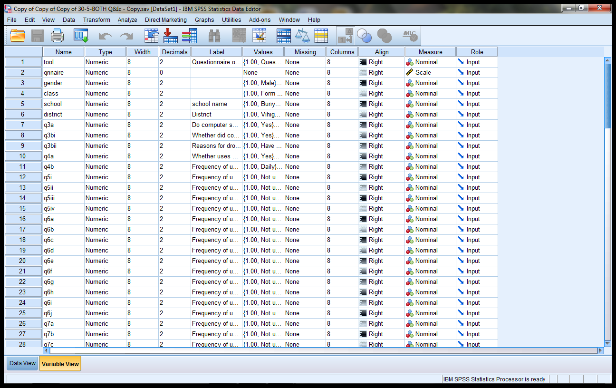
Screenshot 1

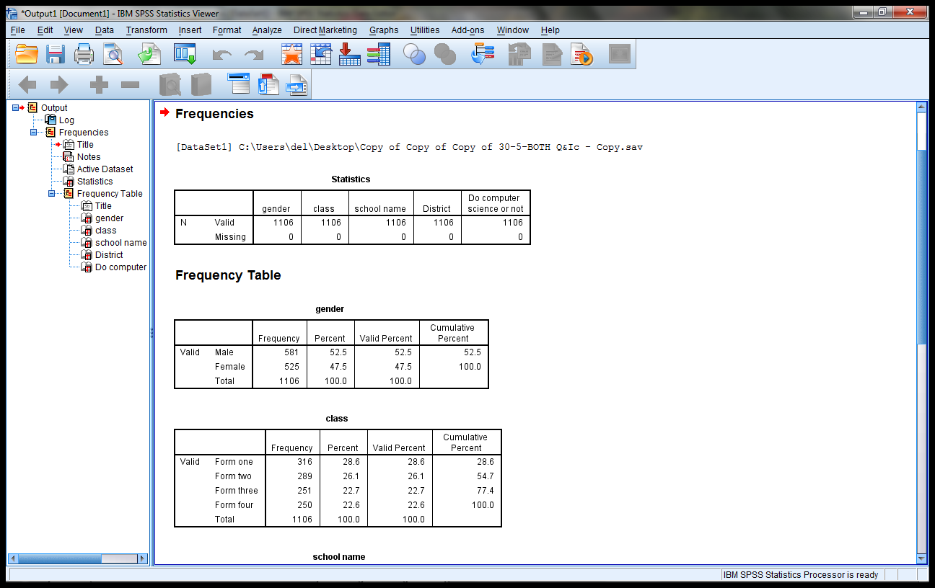
Screenshot 2
a. With reasons, identify the SPSS windows shown in screenshots 1 and 2.
i. Screenshot 1 SPSS window identity (1 mark)
Reasons (2 marks)
ii. Screenshot 2 SPSS window identity (1 mark)
Reasons (2 marks)
b. What are the extensions when saving a:
i. Data editor window (1 mark)
ii. Viewer window (1 mark)
c. Describe how you can define variables in an SPSS programme (12 marks)

QUESTION FIVE
a. Below are tables from an SPSS output concerning descriptive statistics of a certain variable.
Statistics
Gender
N | Valid | 999
N | Missing | 0

Gender
 |  | Frequency | Percent | Valid Percent | Cumulative Percent
Valid | Male | 526 | 52.7 | 52.7 | 52.7
Valid | Female | 473 | 47.3 | 47.3 | 100.0
Valid | Total | 999 | 100.0 | 100.0

i. Explain whether or not the variable was continuous (4 marks)
ii. Describe the procedure for obtaining the descriptive statistics explained in (a) above (6 marks)
b. Below are output tables from an SPSS normality test. Use the tables to answer the questions that follow.
Case Processing Summary
 | Cases
 | Valid |  | Missing |  | Total
 | N | Percent | N | Percent | N | Percent
Which eighth | 999 | 100.0% | 0 | 0.0% | 999 | 100.0%

Descriptives
 |  |  | Statistic | Std. Error
Which eighth | Mean |  | 3.5425 | .06624
Which eighth | 95% Confidence Interval for Mean | Lower Bound | 3.4126
Which eighth | 95% Confidence Interval for Mean | Upper Bound | 3.6725
Which eighth | 5% Trimmed Mean |  | 3.4362
Which eighth | Median |  | 3.0000
Which eighth | Variance |  | 4.383
Which eighth | Std. Deviation |  | 2.09349
Which eighth | Minimum |  | 1.00
Which eighth | Maximum |  | 8.00
Which eighth | Range |  | 7.00
Which eighth | Interquartile Range |  | 3.00
Which eighth | Skewness |  | .559 | .077
Which eighth | Kurtosis |  | -.659 | .155

Tests of Normality
 | Kolmogorov-Smirnovª |  |  | Shapiro-Wilk
 | Statistic | Df | Sig. | Statistic | Df | Sig.
Which eighth | .158 | 999 | .000 | .911 | 999 | .000
a. Lilliefors Significance Correction

i. Using the tables, would you consider the data from which the tables were obtained from to be normally distributed or not. (1 mark)
ii. Justify your answer in (i) above (9 marks)

