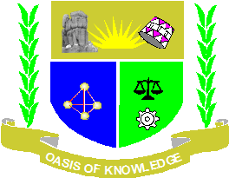
JARAMOGI OGINGA ODINGA UNIVERSITY OF SCIENCE AND TECHNOLOGY
SCHOOL OF EDUCATION, HUMANITIES AND SOCIAL SCIENCES
DEPARTMENT OF SOCIAL STUDIES
UNIVERSITY EXAMINATION FOR THE DEGREE OF BACHELOR OF ARTS IN INTERNATIONAL RELATIONS AND DEPLOMACY WITH IT
4TH YEAR 2ND SEMESTER 2021/2022 ACADEMIC YEAR
NAIROBI CAMPUS
COURSE CODE: ZHB 3404
COURSE TITLE: MEDIA AND INTERNATIONAL RELATIONS
EXAM VENUE:
DATE: 13/07/2022 STREAM: (IR)
TIME: 2.00 HOURS EXAM SESSION: 3.00 – 5.00PM
INSTRUCTION
- Answer question ONE (compulsory) and ANY other TWO question
- Candidates are advised not write on the question paper.
- Candidates must hand in their answer booklets to the invigilator while in the examination room.

QUESTION 1
- What is media technology? (10 marks)
- Briefly explain the media applicable in international relations. (10 marks)
- Assess the ethical approaches that media uses to lead in international relations practice.
(10 marks)
QUESTION TWO
- Analyse the place of media in the east African cooperation. (10 marks)
- Identify the achievements of media in international relations. (10 marks)

QUESTION THREE
With examples, assess the challenges facing the field of media in world politics. (20 marks)

QUESTION FOUR
Trace the evolution of media technology. (20 marks)

QUESTION FIVE
Describe any one theory that supports the use of technology in development of international relations. (20 marks)

