
JARAMOGI OGINGA ODINGA UNIVERSITY OF SCIENCE AND TECHNOLOGY
SCHOOL OF HEALTH SCIENCES

UNIVERSITY EXAMINATION FOR THE DEGREE OF BACHELOR OF SCIENCE IN PUBLIC & COMMUNITY HEALTH
1st YEAR 1st SEMESTER 2016/2017
KISUMU LEARNING CENTRE

COURSE CODE: SCH 3121

COURSE TITLE: ORGANIC CHEMISTRY

EXAM VENUE: STREAM:

DATE: EXAM SESSION

TIME: 2 HOURS

Instructions:

- Answer all questions in Section A and any other 2 questions in Section B

- Candidates are advised not to write on the question paper

- Candidates must hand in their answer booklets to the invigilator while in the examination room

SECTION A
ANSWER ALL THE QUESTIONS (30MKS)
- Name the following molecules (4 mks)

- 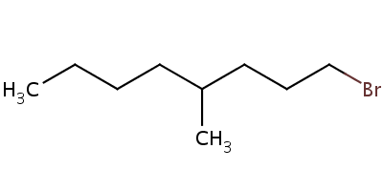
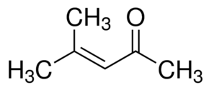

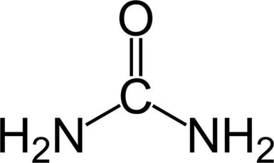

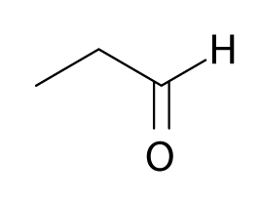
- Draw the structure of the following molecules (6 mks)
- 1-bromo-4-methyloctane
- Ethylphenylether
- 2-methyl-2-butanol
- 4-ethyl-1-methylcyclohexene
- 2-bromo-1,1-dimethylcyclohexane
- 2-methylbutanal
- State two uses of esters (2 mks)
- Ethanol is soluble in water while diethylether is not. Explain (Support your answer using structures) (3 mks)
- Explain why the non-polar side chains of amino acids are unreactive (2 mks)
- Name three significance of nucleic acids (3 mks)
- State four differences between carboxylic acids and alcohols (4 mks)
- Describe the formation of a peptide bond in amino acids (4 mks)
- State two properties of a homologous series (2 mks)

SECTION B
ANSWER ANY TWO (2) QUESTIONS FROM THIS SECTION (20 MKS EACH)
- a) Describe the chemistry of the bacterial cell wall (15mks)
b) Briefly discuss on micelles (5 mks)
- a) Discuss on the saponification process (10 mks)
- Give the mechanism of reaction between hydrogen bromide and diethylether (5 mks)
- Briefly describe sp3 hybridization in hydrocarbons (5 mks)
- a) Discuss on the levels of the protein structure (16 mks)
- With the aid of structures, briefly show how ethylpropanoate is formed (4 mks)
4. a) Discuss on the steps involved in protein synthesis (10mks)
b) Discuss on the components of nucleotide (10 mks)

